# Calculating Beta with CAPM

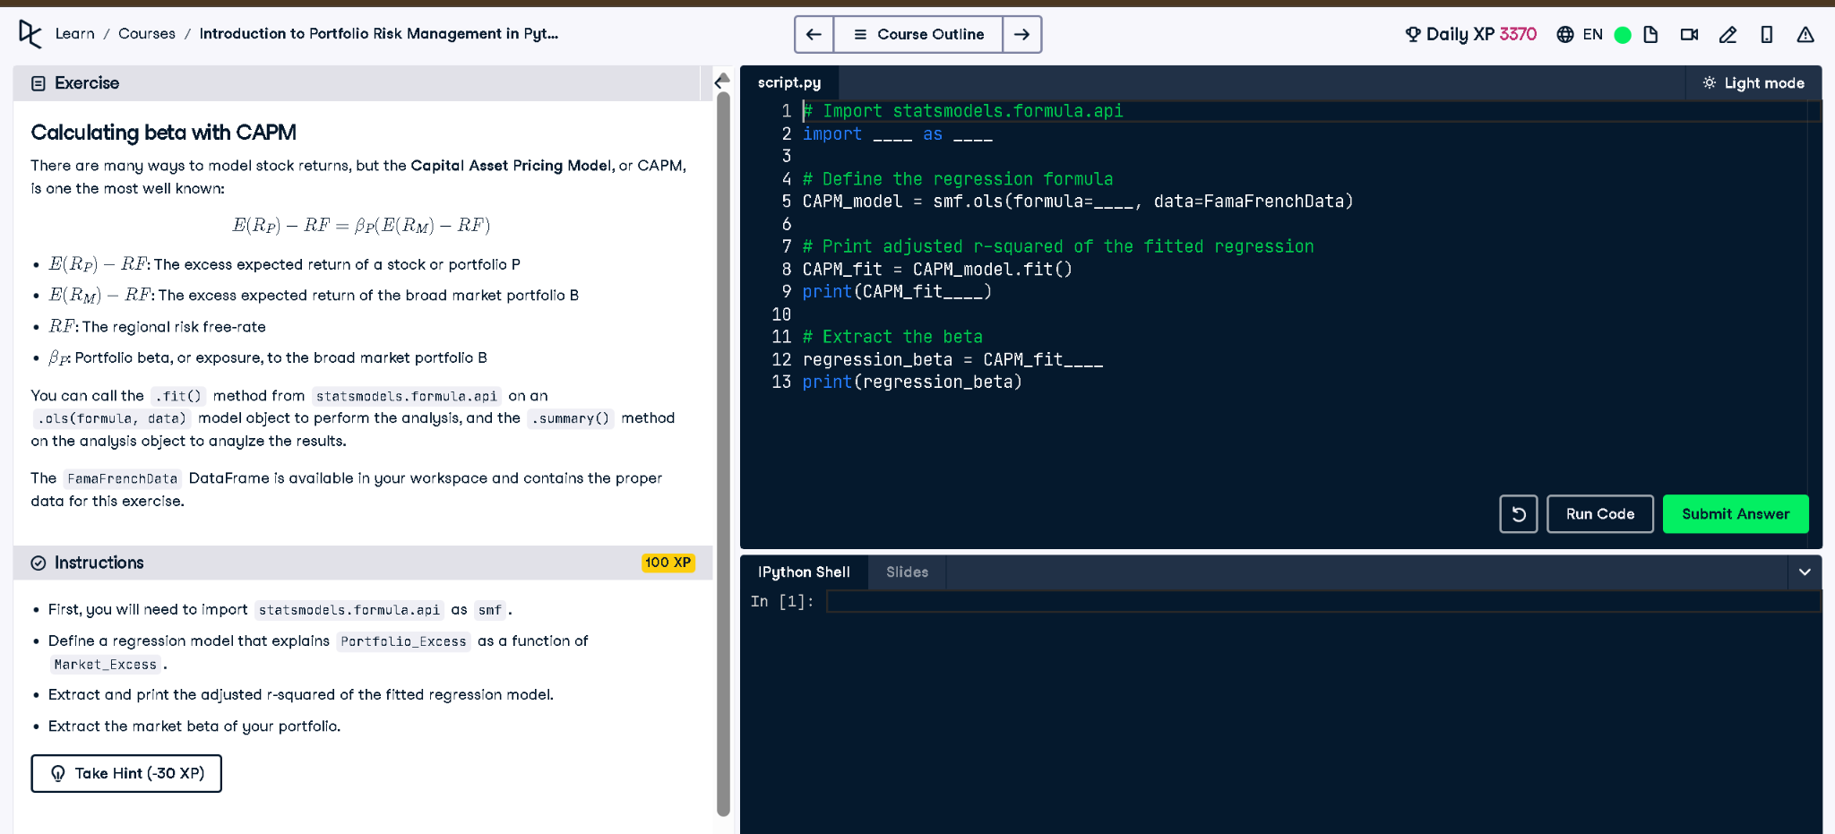

## Python Code

# Import statsmodels.formula.api  
import statsmodels.formula.api as smf  
  
# Define the regression formula  
CAPM_model = smf.ols(formula='Portfolio_Excess ~ Market_Excess', data=FamaFrenchData)  
  
# Print adjusted r-squared of the fitted regression  
CAPM_fit = CAPM_model.fit()  
print(CAPM_fit.rsquared_adj)  
  
# Extract the beta  
regression_beta = CAPM_fit.params['Market_Excess']  
print(regression_beta)

## Explanation

This code uses the Capital Asset Pricing Model (CAPM) to estimate the beta of a portfolio. Beta measures how much the portfolio's returns respond to movements in the overall market. By running a linear regression with the market excess return as the independent variable and the portfolio excess return as the dependent variable, we get the beta value as the slope coefficient. The adjusted R-squared tells us how well the model explains the variability in portfolio returns.